**A PROJECT REPORT**

**ON**

**KEY TO SAFETY**

*Submitted by*

**Janki Purohit [170410107090]**

**Priyansh Suthar [170410107117]**

**Vaidehi Vani [170410107123]**

***In partial fulfilment***

***Of***

**BACHELOR OF ENGINEERING**

***in***

**COMPUTER ENGINEERING**



**SARDAR VALLABHBHAI PATEL INSTITUTE OF TECHNOLOGY,**

**VASAD**

**Gujarat Technological University, Ahmedabad**

**2020-2021**

**SARDAR VALLABHBHAI PATEL INSTITUTE OF TECHNOLOGY, VASAD**

**COMPUTER ENGINEEERING DEPARTMENT**



**CERTIFICATE**

**Date: 04/12/2020**

**This is to certify that the project entitled “KEY TO SAFETY” has been carried out by JANKI PUROHIT (170410107090), PRIYANSH SUTHAR (170410107117), VAIDEHI VANI (170410107123) under my guidance in partial fulfilment of the project in Bachelor Of Engineering in Computer Engineering 8th semester of Gujarat Technological University, during the academic year 2019-2020.**

**Internal Guide: Head of Department:**

**Prof. Parul V. Bakaraniya Prof. Dr. Neha Soni**

**Assistant Professor C.E. Department**

**S.V.I.T. Vasad S.V.I.T. Vasad**

**ACKNOWLEDGEMENT**

We would like to thank our project internal guide Prof.  **Parul V. Bakaraniya**, (Computer engineering department SVIT, Vasad) for providing a vision about the project. We have been greatly benefited from the well-organized critical reviews and inspiration throughout our work.

We would also like to thank our faculty members for their unfailing cooperation and their valuable time to assist us in our work. We have developed not only technical skills but also learned all those qualities required to become a good professional engineer.

Last but not least, we would like to mention here that we are greatly thankful to each and everybody who has been associated with this project at any stage but whose name does not find a place in this acknowledgement.

**ABSTRACT**

A KEY TO SAFETY as the name suggests that this is related to the Health Care Department/ Doctors/ Patients/ etc. As previously given here that Our Project Name suggests that Our Moto is to provide the safety to all the users. As we know that our country faces various pandemic from time to time. In that, every individuals are facing many difficulties and suffer to get safety kit and safety products related that dieses. In this crucial situation, our web-application mainly focuses on increasing the awareness in the people. This website initially work like this, there is a different Login ‘IDs & Passwords’ for Admin, Supplier, Customer. Where after Generation of the Login IDs, Customer can shop safety product like face masks, face shield, sanitizers etc. according to their requirement and also compare their price from other different websites. There is another window for the Information Purpose at where they can see different news regarding the current situation or current medical condition through which awareness of particular dieses is spread in the people. Our web-application also provides information about that pandemic in their regional language.

Our Project will help the society by many ways. Firstly, doctors or patients or any other customer can buy all their needful medical kit from our website. Second, they can also compare the price of the same products with the other websites at the same time. Thirdly, they can see news regarding current circumstances and last but not least if customer does not familiar with English language then they can also use this website in their local language.

**Contents:**

|  |  |  |
| --- | --- | --- |
| **1.** | **Introduction** | **7** |
| 1.1 | Project Summary | 7 |
| 1.1.1 | Why you made this project | 7 |
| 1.2 | Project Details | 7 |
| 1.2.1 | Where your project or innovation will use | 6 |
| 1.2.2 | How it works | 7 |
| 1.3 | Sodh Yatra | 8 |
| 1.4 | Aim and Objectives of Project | 8 |
| 1.5 | Project Specification | 8 |
| 1.5.1 | The main work of project | 8 |
| 1.6 | Plan of project | 8 |
| 1.7 | Work Plane(Timeline Chart) | 9 |
| **2.** | **Requirement Specification** | **10** |
| 2.1 | Functional Requirement | 10 |
| 2.2 | Non-Functional Requirement | 11 |
| 2.3 | Hardware Requirement | 12 |
| 2.4 | Software requirement | 13 |
| 2.5 | Feasibility Study | 14 |
| 2.5.1 | Economic Feasibility | 14 |
| 2.5.2 | Technical Feasibility | 15 |
| **3** | **System Design** | **16** |
|  | System Architechture | **16** |
| 3.1 | System Diagrams | 17 |
| 3.1.1 | Activity Diagram | 17 |
| 3.1.2 | Class Diagram | 20 |
| 3.1.3 | Use Case Diagram | 21 |
| 3.1.4 | Data Flow Diagram | 23 |
| 3.1.5 | Data Dictionary | 25 |
| **4.** | **System Description** | **27** |
| 4.1 | Software Description (Visual Studio) | 27 |
| **5.** | **Conclusion & Future Scope** | **28** |
|  | **Reference : Canvas** | **29** |
|  | Appendix A |  |
|  | Appendix B |  |

**Chapter 1: Introduction**

# Project Summary

* + 1. **Why you made this project?**

→As we know, sometimes due to natural disasters all the people are unable to get all the safety products to survive that situation and also it is not possible to get the safety products , due to this irregularities there are many loses faced by company every year.

→So, we planned to make this project for the customer and help them to receive the needful product.

# Project Details

* + 1. **Where your project or innovation will use?**

→As it is a project of Equanimous Technologies Company and it is a business project as well as ecommerce platform which provide several products to help and sustain in adverse condition.

* + 1. **How it works?**

→ We gather information like what are the current trends in the market and which technology preferred by companies nowadays.

→ We faces several difficulties for how to find proper definition which suites to the final year level and which technology and language is help us for our future development.

→ To find appropriate definition and technology we need guidance of any experience person as well as internet who give us proper suggestion or answer of our all questions.

→ We studied different case studied and research papers which were made by different expertise as well as we use Google to explore more.

* 1. **Sodh Yatra** :—

At the time of Novel Corona Virus Pandemic, we are looking for a good and ideal project definition for our Last Year Project. We discussed a lot on the how the world is changing and the world need the combination of the technology and health at the same time. So, we decided to go for a project that can be directly purchase the health care require product or safety instruments.

We discussed a lot on the how the situation is changing and the people need the combination of the technology and health at the same time. So, we decided to take help someone or work on ongoing project which is related to the online buying and selling ecommerce website project.

So as previous we are ready to make a project on healthcare issue. So, after the whole discussion we talked about the customer’s end and supplier’s end that how they will use our website or by using which technology we can develop this website.

For that we referred one Indian website which is slightly similar to our main idea of the web-application.

* 1. **Aim and Objectives of Project**

**Aim**: The purpose of “KEY TO SAFETY” is to manage information of customers and suppliers as well as provide several protective products that they can use it for sustaining in crucial time.

This project that helps supplier to sell their varieties of products according to the needs of customers. Moreover, it also provide a platform which offers multiple language support.

# Project Specification

* + 1. **The main work of project**

→We planned to make this project for the customers and help them to get their requirements using several technologies.

→Now this is a project for ecommerce usage, we are making a web-application to provide Products to the customer and now it is easy to get them all the needy items online with several features.

# Plan of project

To start implementing the project, first we planned for this project that how we start and from where we start this. So first of all we collect the information about this project so that we can make it easy to implement further.

Next we design some working diagrams by fully understanding the project and make flowcharts, activity diagrams etc. Next we start collecting and making databases that are required for this project and further implementation is still going on.

# Work Plan(Timeline Chart)

|  |  |  |  |  |  |
| --- | --- | --- | --- | --- | --- |
| Description | June-July | August | September | October | November |
| Title |  |  |  |  |  |
| Objective analysis |  |  |  |  |  |
| Diagrams and Data-Dictionary |  |  |  |  |  |
| Canvases and Modules |  |  |  |  |  |
| Primary Report |  |  |  |  |  |
| Start Implementation |  |  |  |  |  |

**Chapter 2: Requirement Specification**

# Functional Requirement

A functional requirement document defines the functionality of a system or one of its subsystems. It also depends upon the type of software, expected users and the type of system where the software is used.

Functional user requirements may be high-level statements of what the system should do but functional system requirements should also describe clearly about the system services in detail.

* + - Registration and Login
      * User
      * Supplier
      * Admin
      * Notification
      * User
      * Supplier
      * Admin
    - Customer can get notification / view about product offers and discount
    - Supplier can upload their product information
    - Payment method
    - Customer can get the summary of all product
    - Bill
      * Download by Customer
      * Generate by Supplier
    - Help us and contact us

# Non-Functional Requirement

Basically, Non-functional requirements describe how the system works**,** while functional requirements describe what the system should do**.**

This does not mean the latter are more important, but most requirement gathering techniques focus on functional requirements**,** so large gaps in non-functional requirements are common.

So what exactly are we looking for here? Well, here are eight examples of Non- Functional requirement groups**;** Security, Privacy, Scalability and Performance, Speed of Web services Documentations, Data integrity and Retention, Search, Availability.

**Security** – it is important to specify the level of security that should be met the requirement of end user.

**Privacy** – meeting basic requirements

**Scalability and performance** – ensuring that the system can scale to meet expected traffic and order volume at normal and peak times

**Speed of web services** – defining how long web services will take to provide a response

**Documentation** – ensuring that the platform is sufficiently documented

**Data integrity and retention** – defining how long data should be stored and how the integrity of data is maintained

**Search** – defining how quickly the system will return search results

**Availability** – defining the agreed uptime of the platform under normal conditions

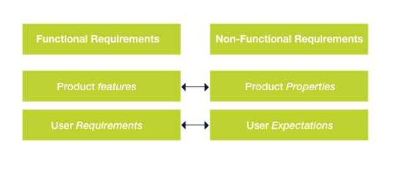

# Hardware Requirement

**Hardware:** Laptop / Tablet

Mobile devices

PC

Minimum Ram: 512Mb

Internet

External Hard Drive for backup

Camera

Server

# Software Requirement

**Software:** Application Software: Browser (Mozilla Firefox. Internet Explorer, Google Chrome)

Operating System: Windows7 Ultimate which supports networking.

Visual studio latest version with MVC tools and requirements

Diagram designer to draw diagrams.

MS-PowerPoint to present the project demo.

Database for storing the information

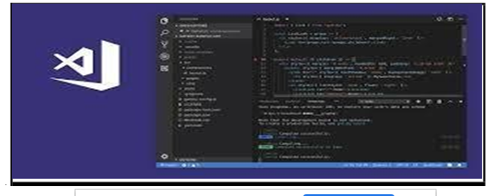

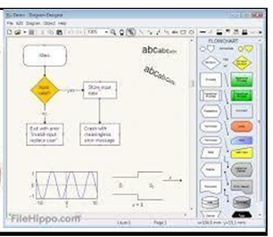

# Feasibility Study

* + 1. **Economic feasibility**

It refers to the benefits or outcomes we are deriving from the product as compared to the total cost we are spending for developing the benefits are more or less the same as the older system then it is not feasible to develop the product.

The product is economical feasible.

The product is feasible for following criteria.

Reduce the processing time

Reduce the work-load

The cost for this project will not go too much high

Value is consider as applying such cost to implement the project



# Technical feasibility

**What is technical feasibility?**

Technical feasibility study assesses the details of how you will deliver a product or service (i.e., materials, labor, transportation, where your business will be located, technology needed, etc.).

Think of the technical feasibility study as a logistical or tactical plan of how your business will produce, store, deliver and track its products or services.

**Technical feasibility**

The only risk for using this project idea is that without internet connectivity the work is incomplete and also chances for information lost if in between the work internet connectivity lost. So when product are delivered with their product-id, at that time there is possibility of losing product-id due to poor network connection.

**Solution**

We have provided good service even if there is a low bandwidth or poor network connection.

**Chapter 3: System Design:**

**System Architecture:**

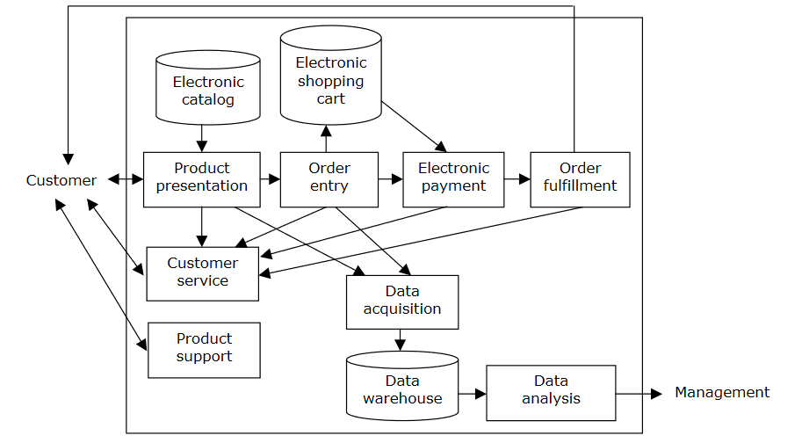

# System Diagrams

# Activity diagram for User side

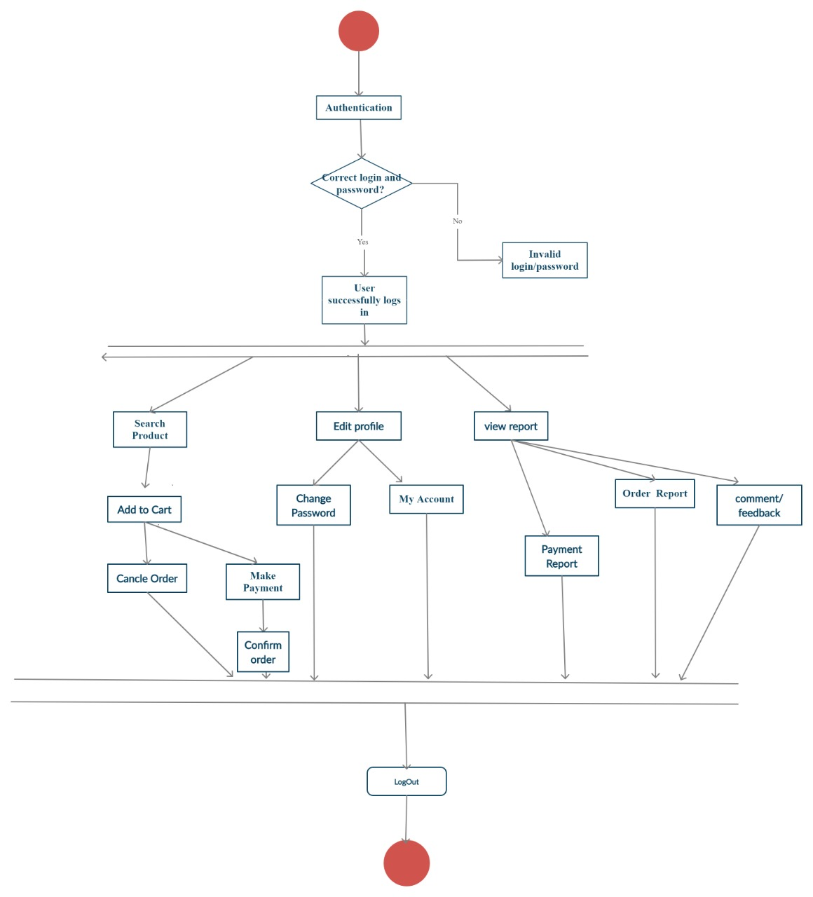

**Fig.3.1.1(a) Activity Diagram User Side**

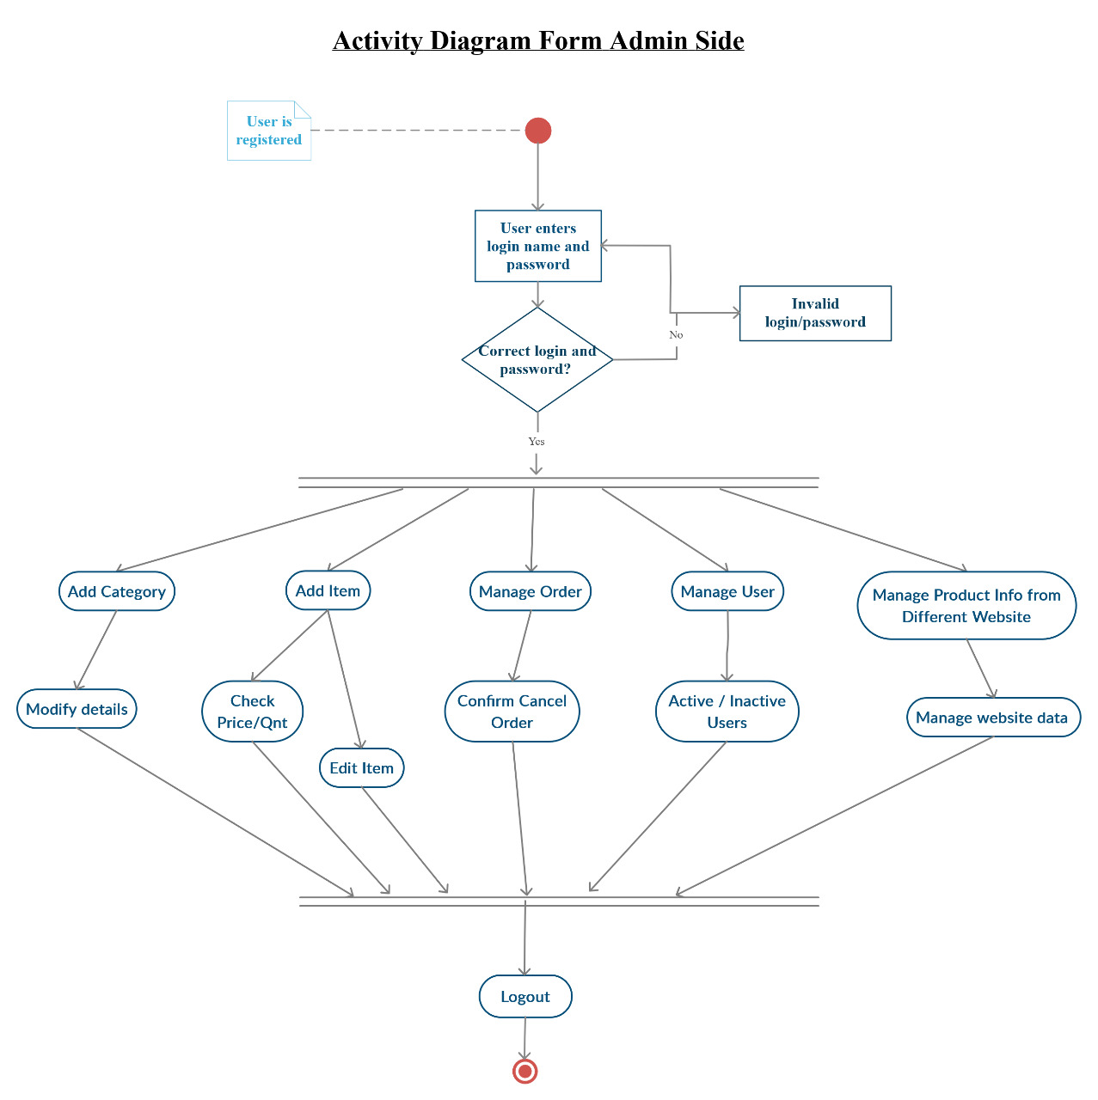

**Fig.3.1.1(b) Activity Diagram Admin side**

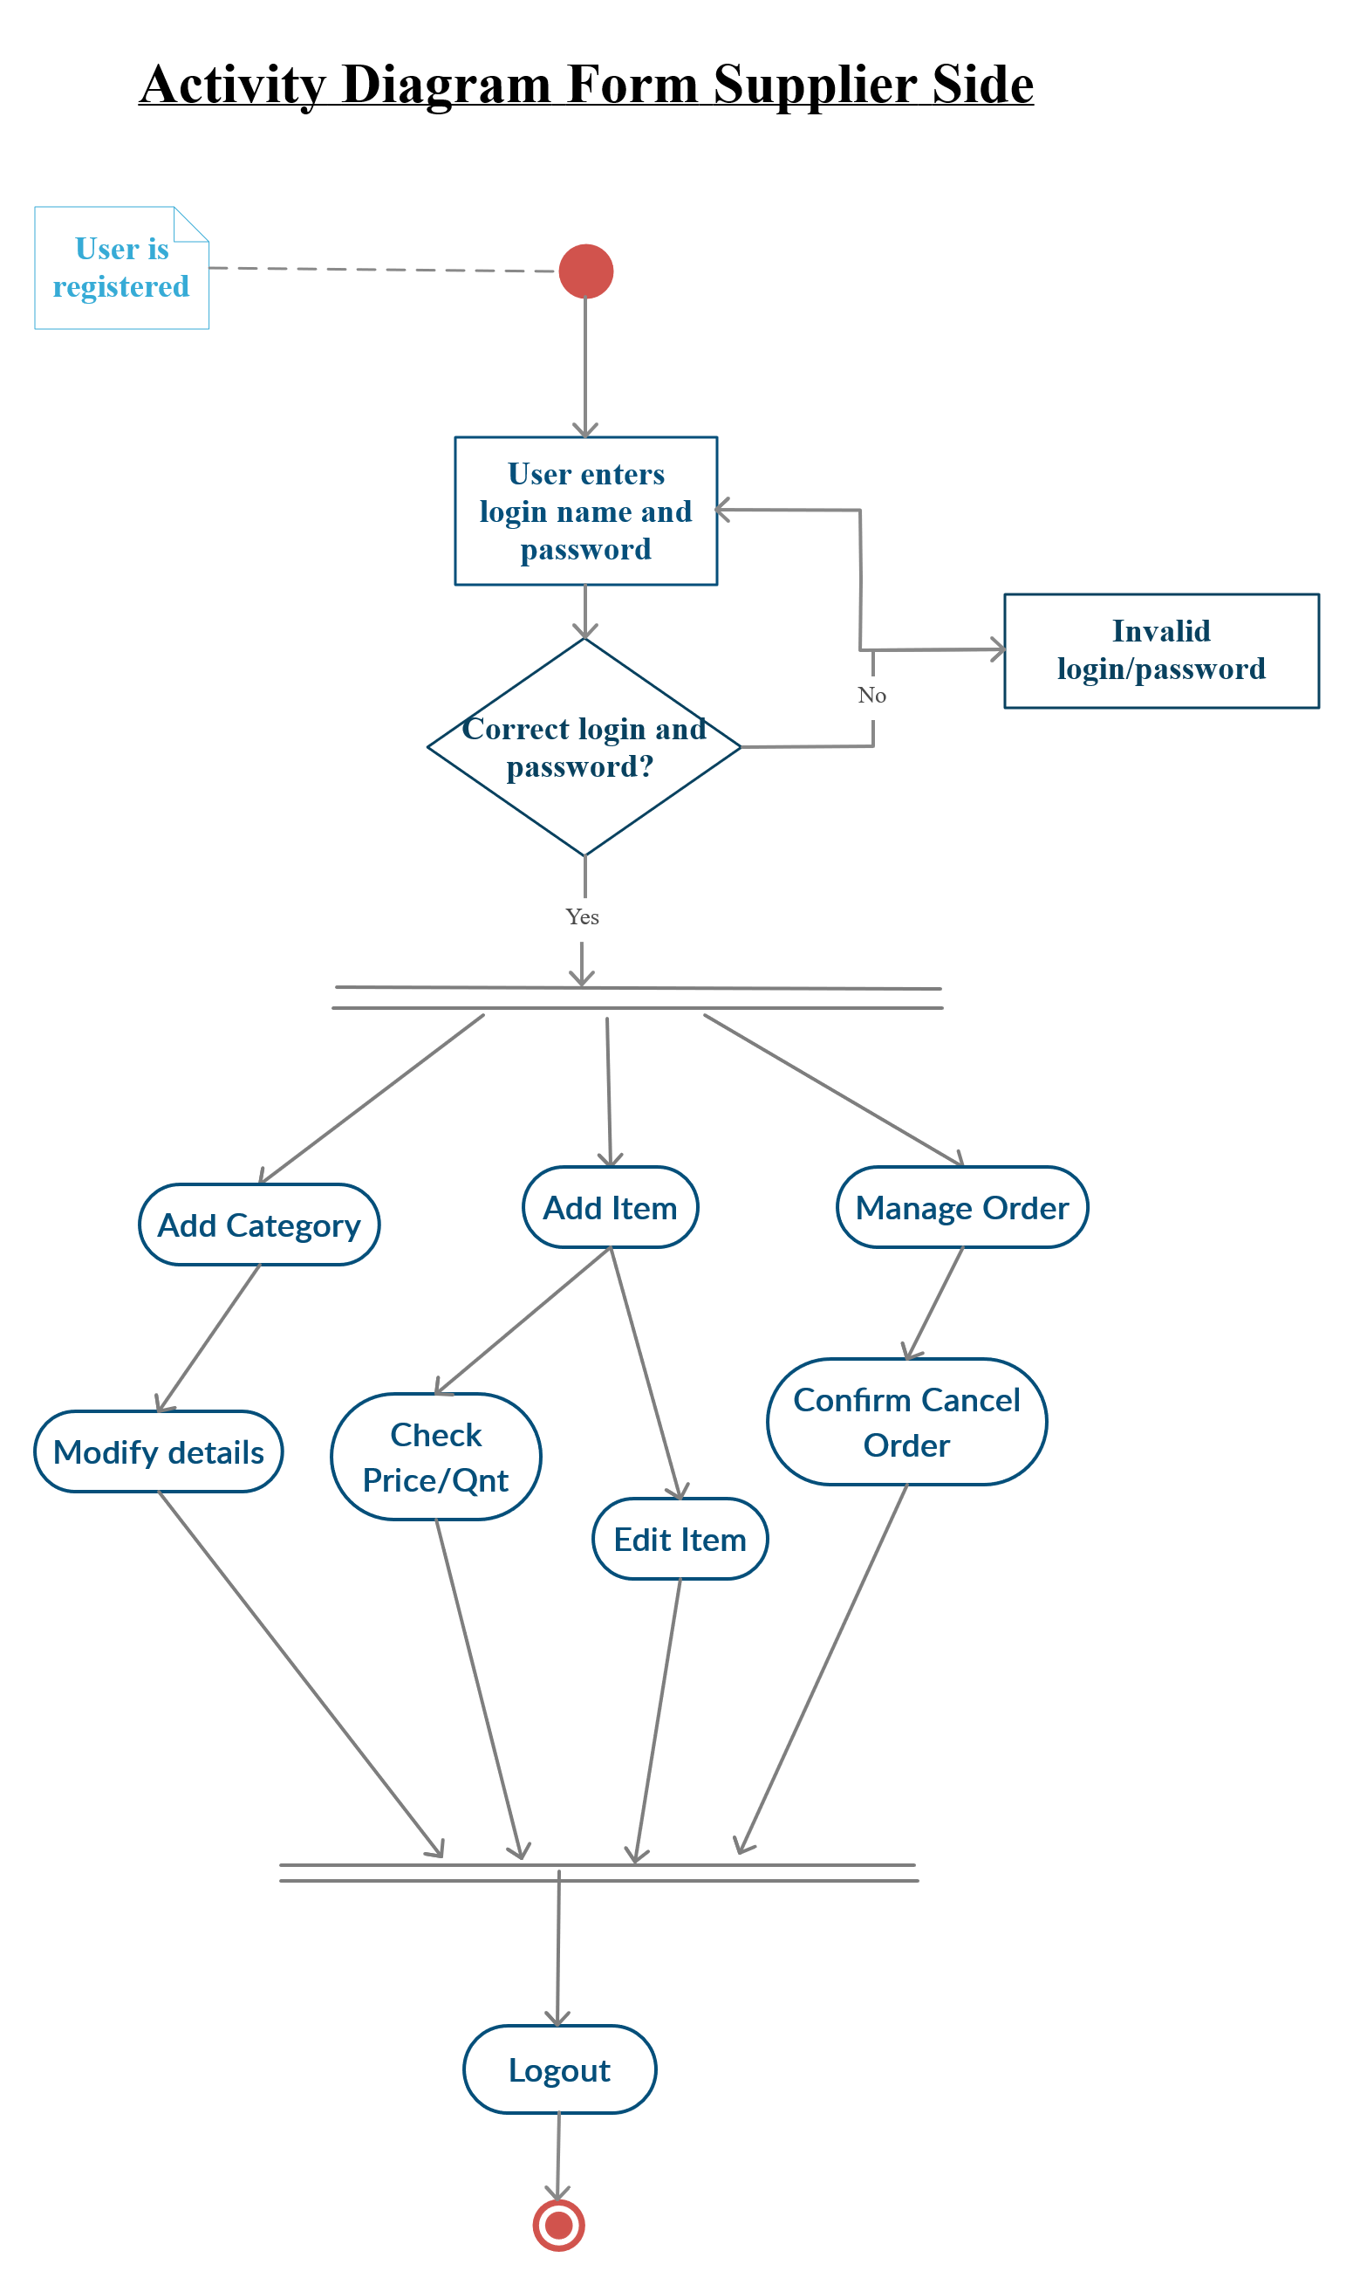

**Fig.3.1.1(c) Activity Diagram Supplier Side**

# Class diagram

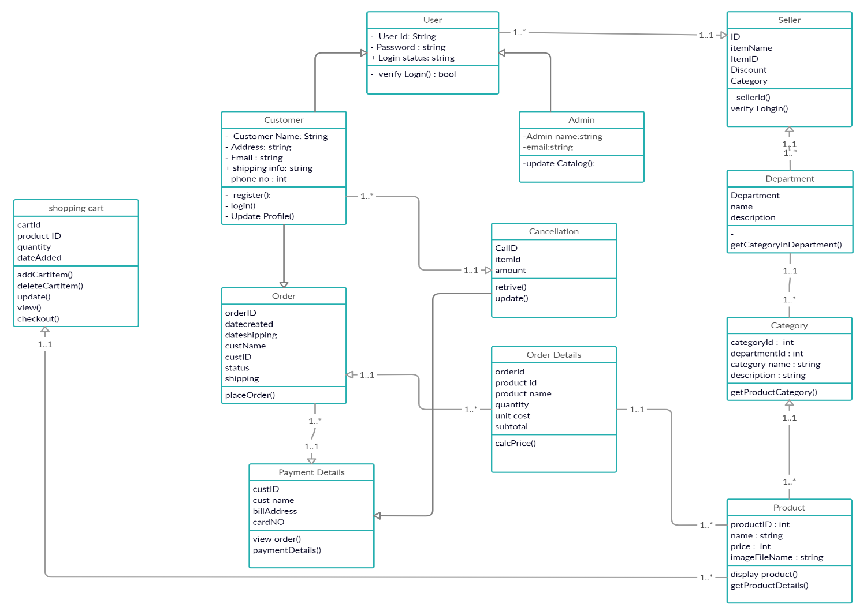

**Fig.3.1.2 Class Diagram**

# Use Case

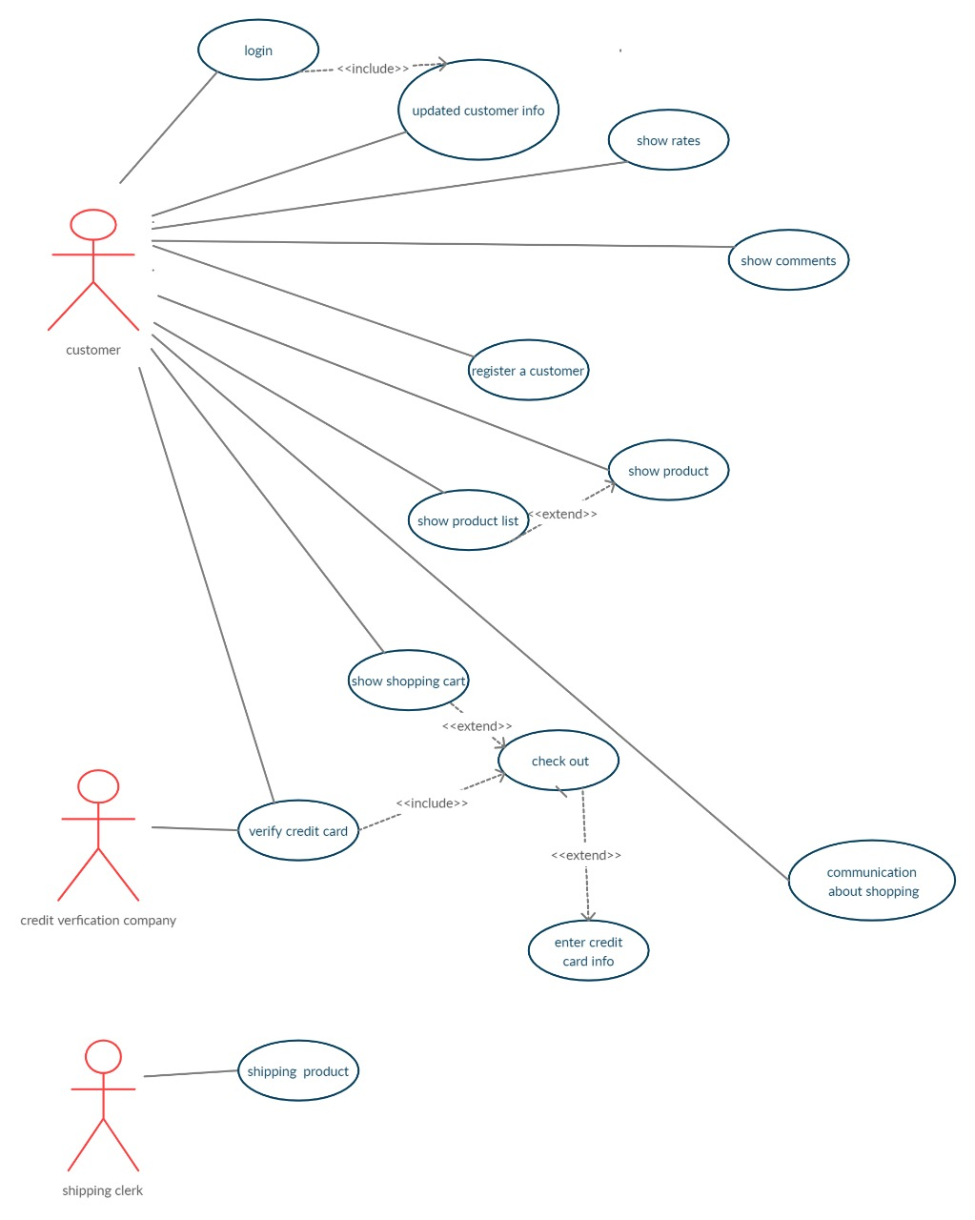

**Fig.3.1.3(a) Use Case**

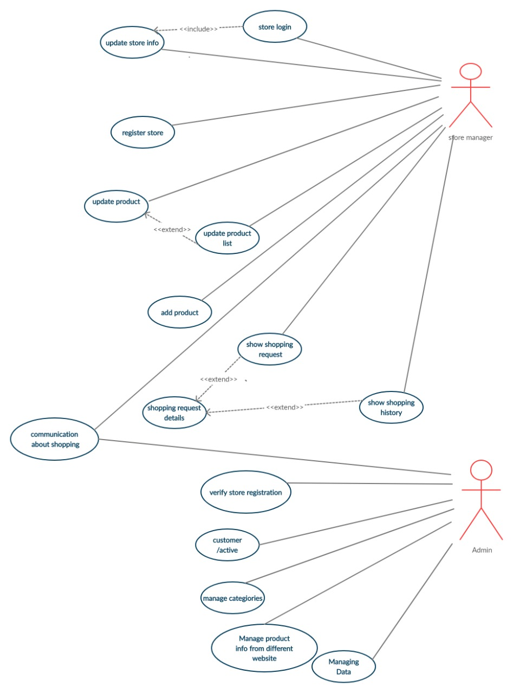

**Fig.3.1.3(b) Use Case**

# Data Flow- diagram

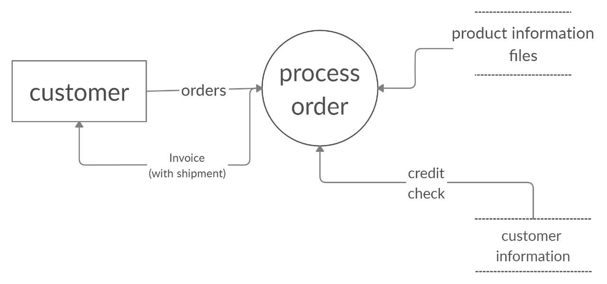

**Fig.3.1.4(a) Zero Level DFD**

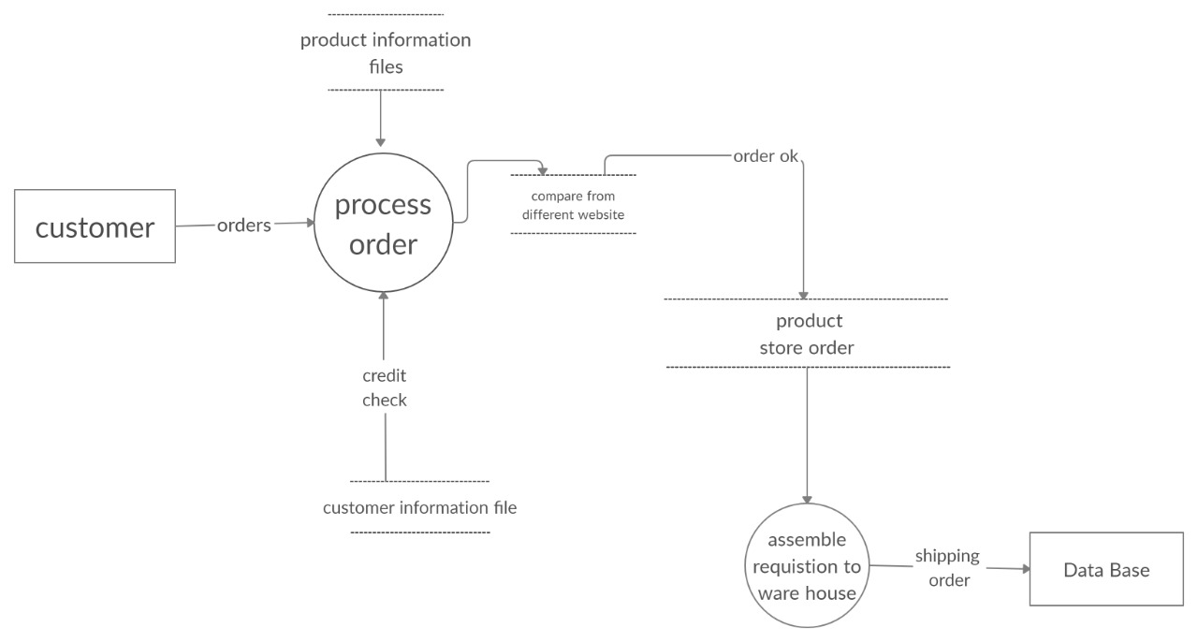

**Fig.3.1.4(b) First Level DFD**

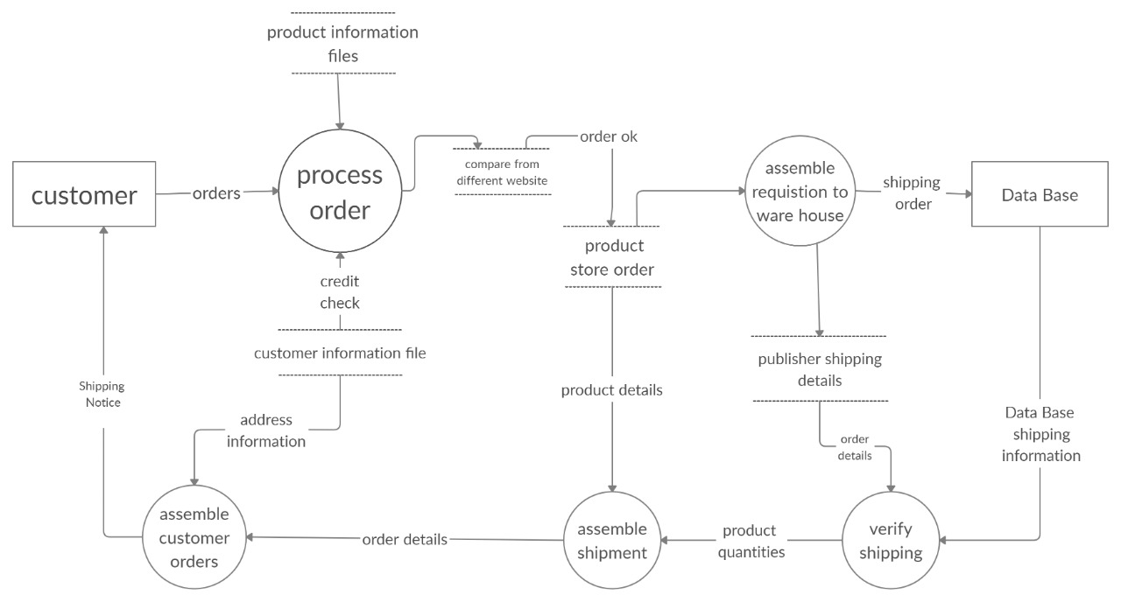

**Fig.3.1.4(c) Second Level DFD**

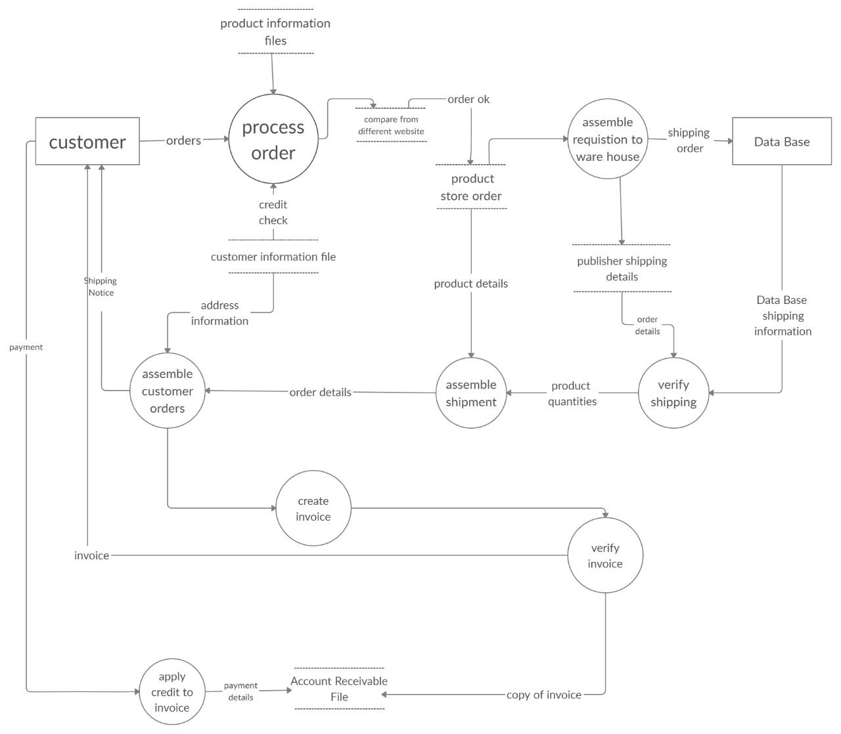

**Fig.3.1.4(d) Third Level DFD**

# Data Dictionary

**Table 3.1.5.1: Customer Database**

|  |  |  |
| --- | --- | --- |
| **Field Name** | **Data Type** | **Constraint** |
| CustNo | Varchar (50) | Primary Key |
| Password | Varchar(20) | Not Null |
| Name | Varchar(20) | Not Null |
| Gender | Bit | Not Null |
| Email | Varchar(20) | Not Null |
| Mobile | Numeric(20,0) | Not Null |
| Location | Varchar(20) | Not Null |

**Table 3.1.5.2: Product Database**

|  |  |  |
| --- | --- | --- |
| **Field Name** | **Data Type** | **Constraint** |
| Product_Id | Numeric(18,0) | Primary key |
| Product_Name | Varchar(20) | Not Null |
| Company | Varchar(50) | Not Null |
| Model | Varchar(50) | Not Null |
| SerialNumber | Varchar(50) | Not Null |
| PurchaseDate | Date | Not Null |
| Status | Char(50) | Not Null |

**Table 3.1.5.3: Product Shipping Database**

|  |  |  |
| --- | --- | --- |
| **Field Name** | **Data Type** | **Constraint** |
| Product_Id | int | Primary key |
| Cust_Id | Varchar(50) | Not Null |
| Cust_Address | Varchar(20) | Not Null |
| Cust_city | Varchar(20) | Not Null |
| Cust_state | Varchar(20) | Not Null |
| Cust_Country | Varchar(20) | Not Null |
| Cust_pincode | Varchar(20) | Not Null |
| Cust_phoneno | Int(10) | Not Null |

**Table 3.1.5.4.: Supplier Database**

**/**

|  |  |  |
| --- | --- | --- |
| **Field Name** | **Data Type** | **Constraint** |
| SupplierNumber | Varchar(50) | Primary Key |
| SupplierName | Varchar(50) | Not Null |
| Address | Varchar(50) | Not Null |
| Mobile | Numeric(20,0) | Not Null |
| Email | Varchar(50) | Not Null |
| GSTNumber | Varchar(50) | Not Null |
| Location | Varchar(50) | Not Null |

**Table 3.1.5.5: Login Database**

|  |  |  |
| --- | --- | --- |
| **Field Name** | **Data Type** | **Constraint** |
| Email | Varchar(30) | Primary Key |
| Role | Varchar(20) | Not null |
| Password | Password(100) | Not Null |

|  |  |  |
| --- | --- | --- |
| **Field Name** | **Data Type** | **Constraint** |
| OTP Varification | Int | Primary Key |

**Table 3.1.5.6Authentication Database**

**Chapter 4: System Description.**

# 4.1 Software description (Visual studio).

Microsoft Visual Studio is an [integrated development environment](https://en.wikipedia.org/wiki/Integrated_development_environment) (IDE) from [Microsoft](https://en.wikipedia.org/wiki/Microsoft). It is used to develop [computer programs,](https://en.wikipedia.org/wiki/Computer_program) as well as [websites,](https://en.wikipedia.org/wiki/Web_site) [web apps,](https://en.wikipedia.org/wiki/Web_app) [web services](https://en.wikipedia.org/wiki/Web_service) and [mobile apps.](https://en.wikipedia.org/wiki/Mobile_app) Visual Studio uses Microsoft software development platforms such as [Windows API](https://en.wikipedia.org/wiki/Windows_API), [Windows](https://en.wikipedia.org/wiki/Windows_Forms) [Forms,](https://en.wikipedia.org/wiki/Windows_Forms) [Windows Presentation Foundation,](https://en.wikipedia.org/wiki/Windows_Presentation_Foundation) [Windows Store](https://en.wikipedia.org/wiki/Windows_Store) and [Microsoft Silverlight](https://en.wikipedia.org/wiki/Microsoft_Silverlight). It can produce both [native code](https://en.wikipedia.org/wiki/Machine_code) and [managed code](https://en.wikipedia.org/wiki/Managed_code).

Visual Studio includes a [code editor](https://en.wikipedia.org/wiki/Code_editor) supporting [IntelliSense](https://en.wikipedia.org/wiki/IntelliSense) (the [code completion](https://en.wikipedia.org/wiki/Code_completion) component) as well as [code refactoring.](https://en.wikipedia.org/wiki/Code_refactoring) [The integrated debugger](https://en.wikipedia.org/wiki/Microsoft_Visual_Studio_Debugger) works both as a source-level debugger and a machine-level debugger. Other built-in tools include a [code profiler,](https://en.wikipedia.org/wiki/Profiling_(computer_programming)) designer for building [GUI](https://en.wikipedia.org/wiki/GUI) applications, [web designer,](https://en.wikipedia.org/wiki/Web_designer) [class](https://en.wikipedia.org/wiki/Class_(computing)) designer, and [database schema](https://en.wikipedia.org/wiki/Database_schema) designer. It accepts plug-ins that enhance the functionality at almost every level—including adding support for [source](https://en.wikipedia.org/wiki/Source_control) [control](https://en.wikipedia.org/wiki/Source_control) systems (like [Subversion](https://en.wikipedia.org/wiki/Subversion_(software)) and [Git](https://en.wikipedia.org/wiki/Git)) and adding new toolsets like editors and visual designers for [domain-specific languages](https://en.wikipedia.org/wiki/Domain-specific_language) or toolsets for other aspects of the [software development](https://en.wikipedia.org/wiki/Software_development_lifecycle) [lifecycle](https://en.wikipedia.org/wiki/Software_development_lifecycle) (like the [Azure DevOps](https://en.wikipedia.org/wiki/Azure_DevOps_Server) client: Team Explorer).

Visual Studio supports 36 different [programming languages](https://en.wikipedia.org/wiki/Programming_language) and allows the code editor and debugger to support (to varying degrees) nearly any programming language, provided a language- specific service exists. Built-in languages, [Visual Basic](https://en.wikipedia.org/wiki/Visual_Basic_.NET)

[.NET](https://en.wikipedia.org/wiki/Visual_Basic_.NET), [C#](https://en.wikipedia.org/wiki/C_Sharp_(programming_language)), [F#](https://en.wikipedia.org/wiki/F_Sharp_(programming_language)), [JavaScript,](https://en.wikipedia.org/wiki/JavaScript) [TypeScript,](https://en.wikipedia.org/wiki/TypeScript) [XML,](https://en.wikipedia.org/wiki/XML) [XSLT](https://en.wikipedia.org/wiki/XSLT), [HTML](https://en.wikipedia.org/wiki/HTML), and [CSS](https://en.wikipedia.org/wiki/Cascading_Style_Sheets). Support for other languages such as [Python,](https://en.wikipedia.org/wiki/Python_(programming_language)) [Ruby,](https://en.wikipedia.org/wiki/Ruby_(programming_language)) [Node.js,](https://en.wikipedia.org/wiki/Node.js) and [M](https://en.wikipedia.org/wiki/MUMPS) among others is available via [plug-ins.](https://en.wikipedia.org/wiki/Plug-in_(computing)) [Java](https://en.wikipedia.org/wiki/Java_(programming_language)) (and [J#](https://en.wikipedia.org/wiki/J_Sharp)) were supported in the past.

The most basic edition of Visual Studio, the Community edition, is available free of charge. The slogan for Visual Studio Community edition is "Free, fully-featured IDE for students, open-source and individual developers". The currently supported Visual Studio version is 2019.

Initially referred to as Visual Studio "14", the first [Community Technology Preview](https://en.wikipedia.org/wiki/Community_Technology_Preview) (CTP) was released on 3 June 2014 and the [Release Candidate](https://en.wikipedia.org/wiki/Release_Candidate) was released on 29 April 2015; Visual Studio 2015 was officially announced as the final name on 12 November 2014.

Visual Studio 2015 RTM was released on 20 July 2015. Visual Studio 2015 Update 1 was released on 30 November 2015. Visual Studio 2015 Update 2 was released on 30 March 2016. Visual

Studio 2015 Update 3 was released on 27 June 2016.

**Chapter 5: Conclusion & Future scope**

Benefits from Product management strategy appliance are obvious. Also having a good Product management system is one of the most important aspects. In this project report we tried to make an overview of desired features and technical preconditions. Also we tried to value our desirability of such functions and value some of the existing software packages against our methodology. General conclusion is that some of the systems managed to gain high scores in some of the sections excelling in some of the features but failed in the rest of the metrics. Having in mind the need of such systems gives us a motivation for its development.

To develop this project we make use of latest DotNet (MVC) technology, which gave us beneficiary and ease of coding environment and also we will learn web scraping and data mining, we also give best services to the employers through our web-application

Now as all are aware about this web-app so employees can use this app for further valuable Products monitoring and can make updates as per their requirement in this web-application.

**Appendix A : Canvas**

# AEIOU Summary

This canvas deals with the environment, activity, objects, users and interactions done at that particular place.

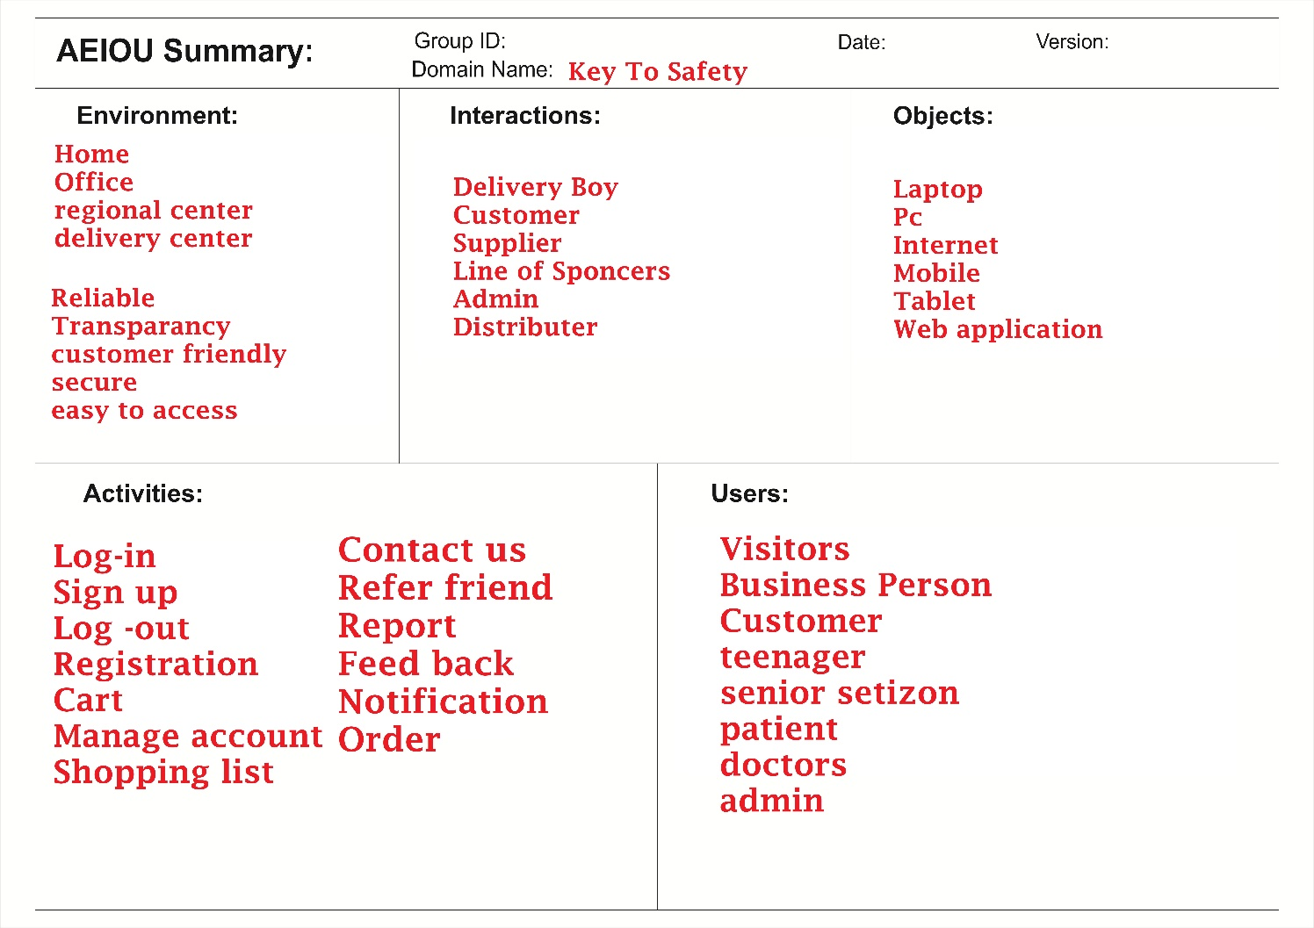

**Fig.6.1 AEIOU Canvas**

# 6.2 Empathy Mapping Canvas

The empathy canvas generally tell us about the positives and the negatives that occurred by considering this project.

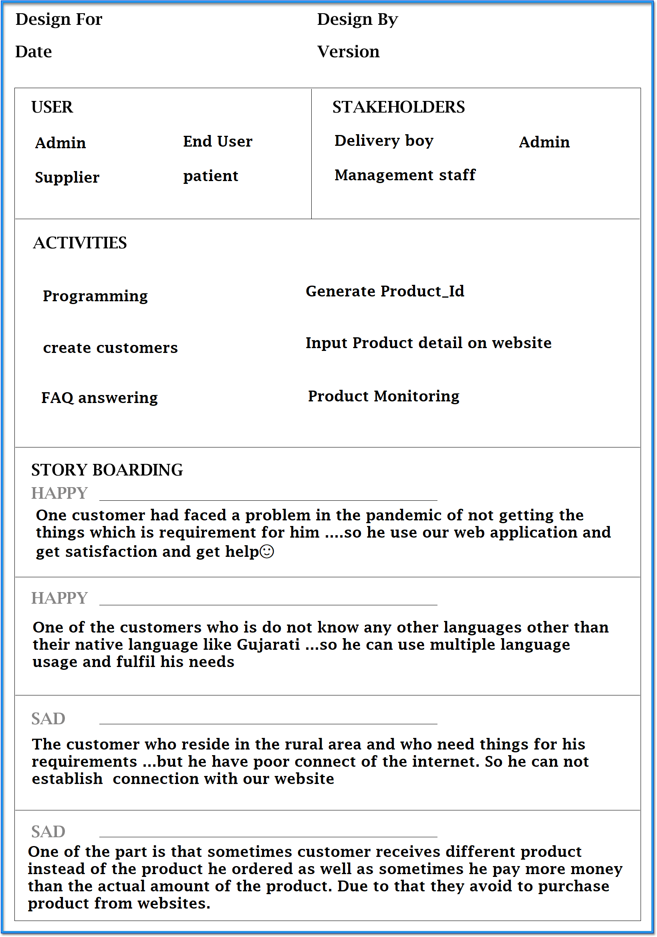

**Fig.6.2 Empathy Canvas**

# Ideation Canvas:

The ideation canvas helps us to generate an idea about the people, activities, and possible solutions to the project.

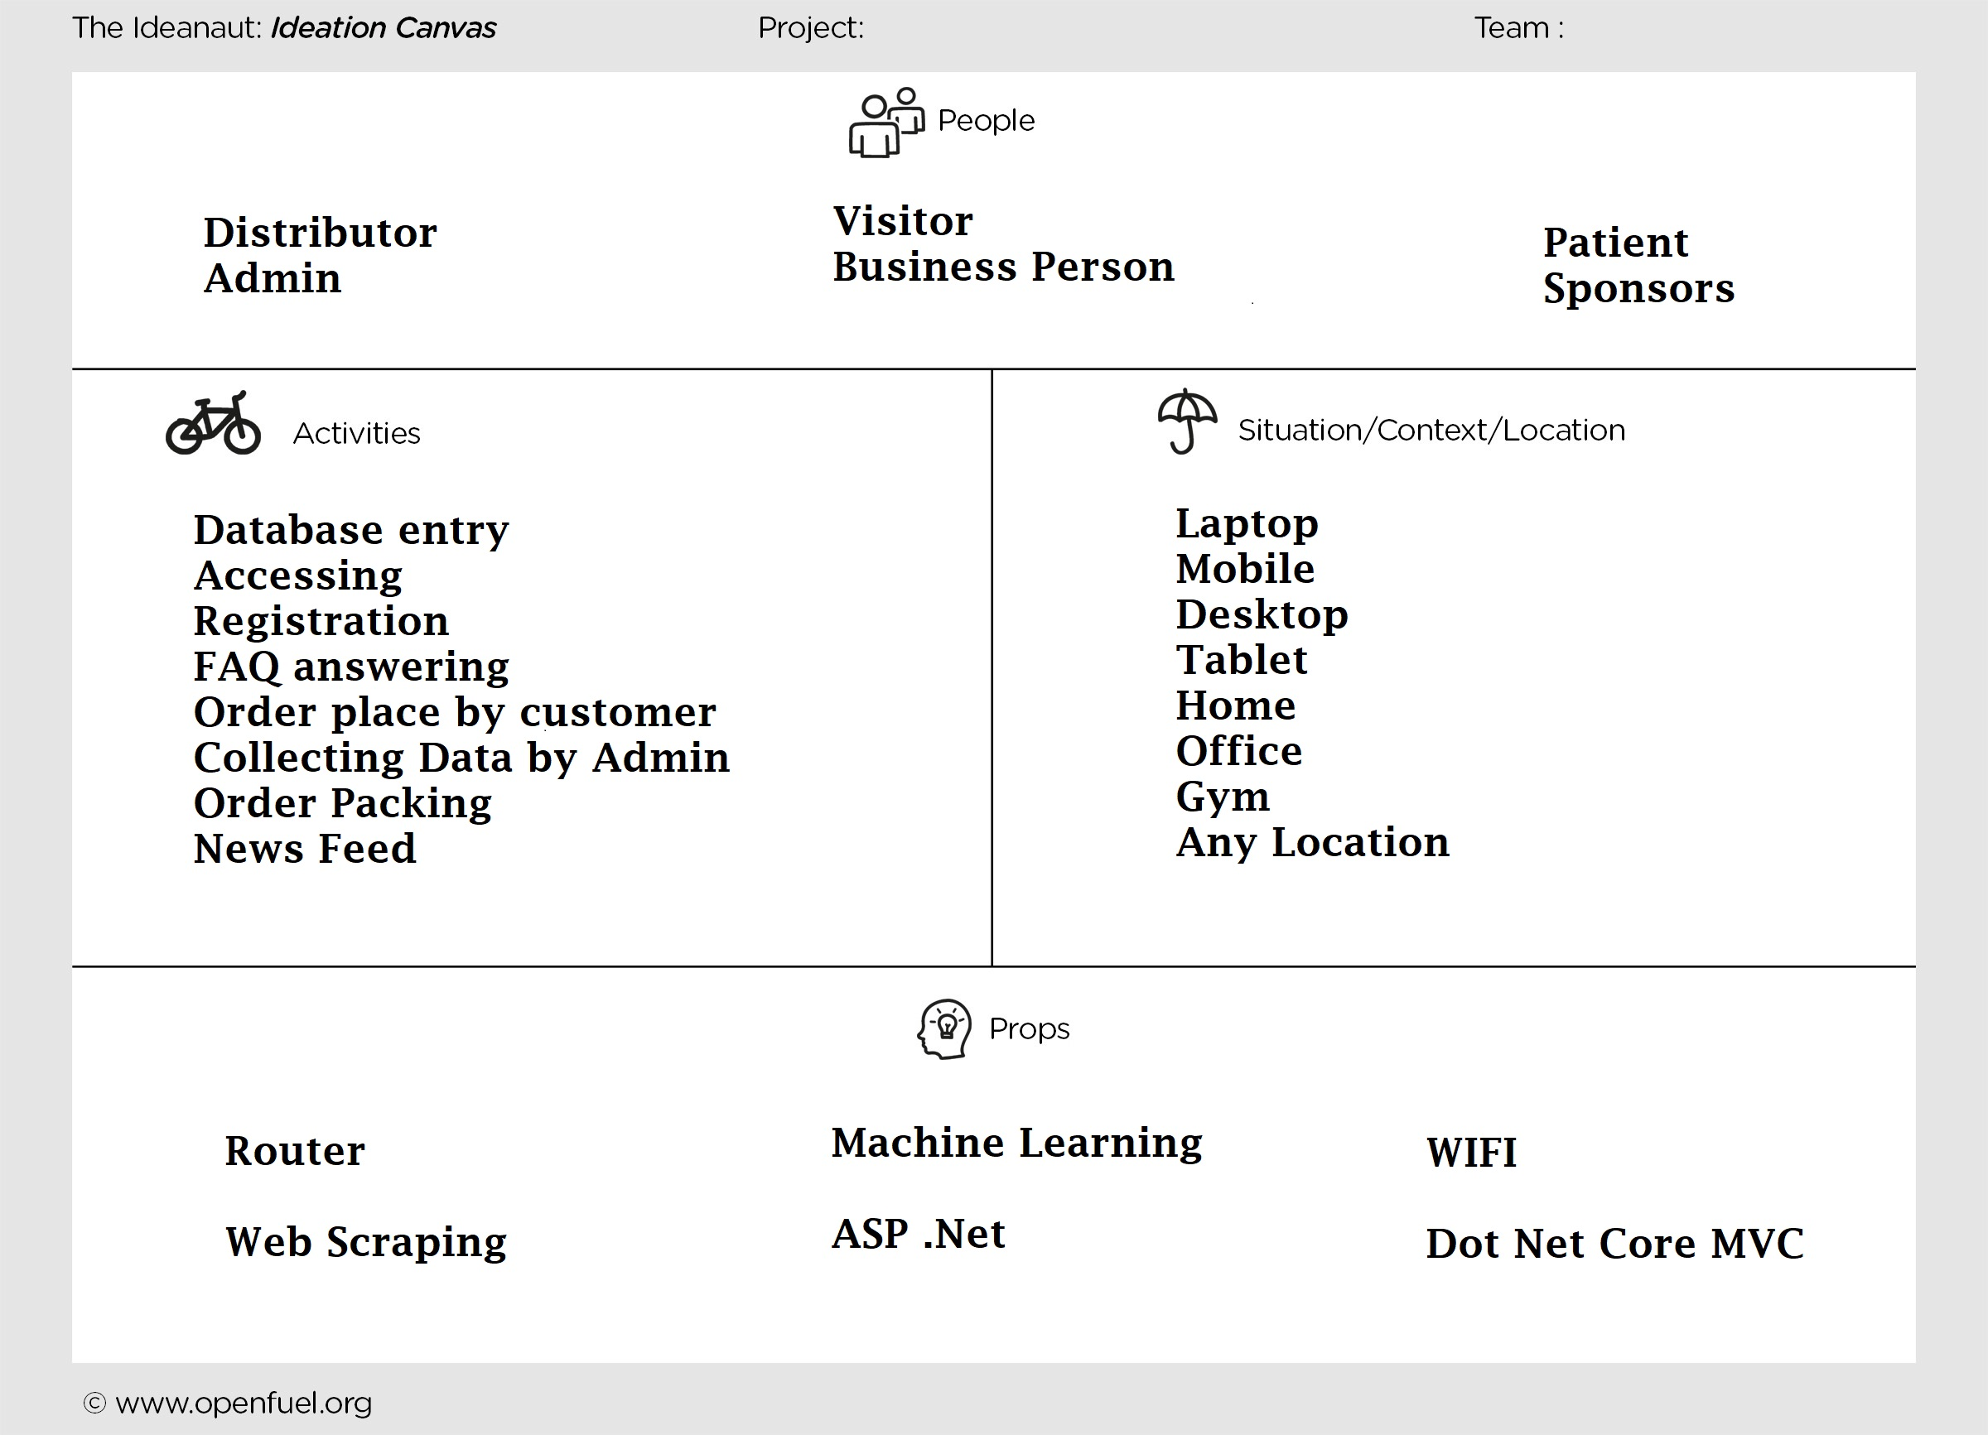

**Fig.6.3 Ideation Canvas**

# 6.4 Product development Canvas:

The product development canvas helps to generate the initial thought of the final product that is to be created by its functions, purpose, features etc.

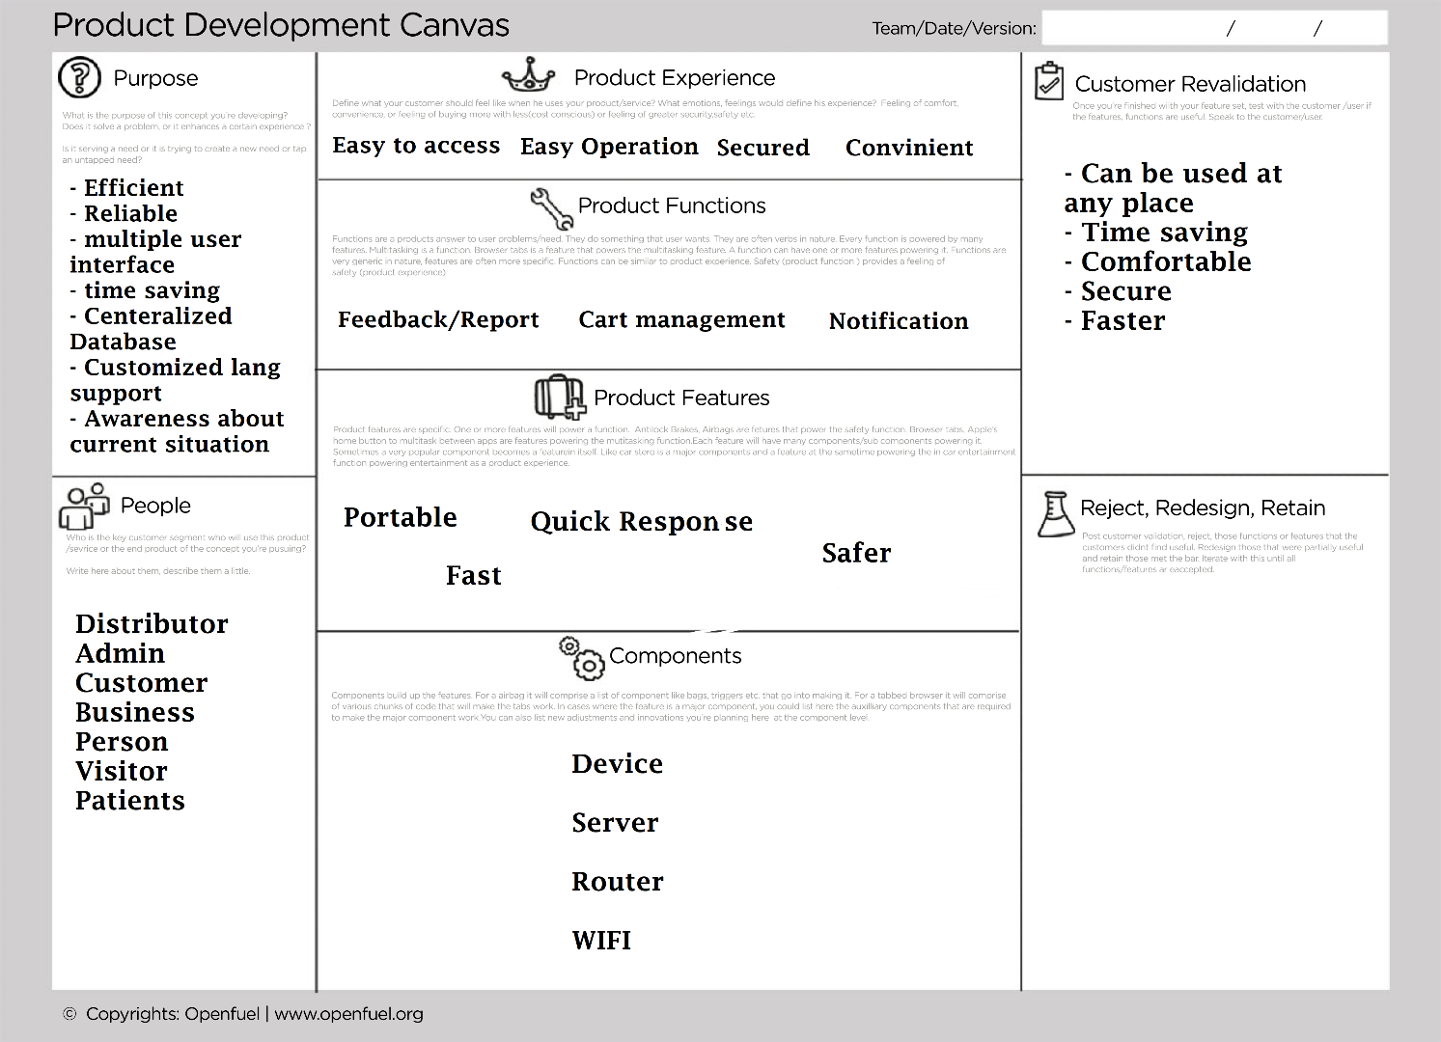

**Fig.6.4 Product development**

**APPENDIX B :**

Here, we implement basic authentication page with basic layout for our web – application.

**Home Page:**

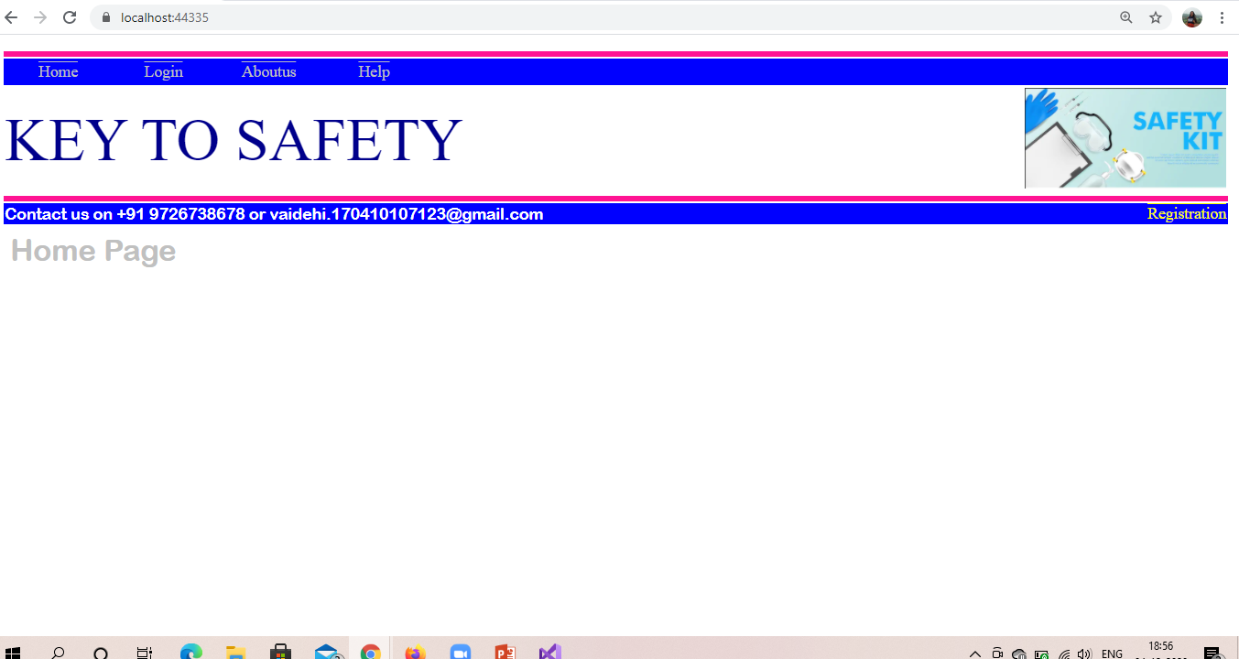

**Registration:**

Here first image shows if user doesn’t fill all the details and click on submit button.

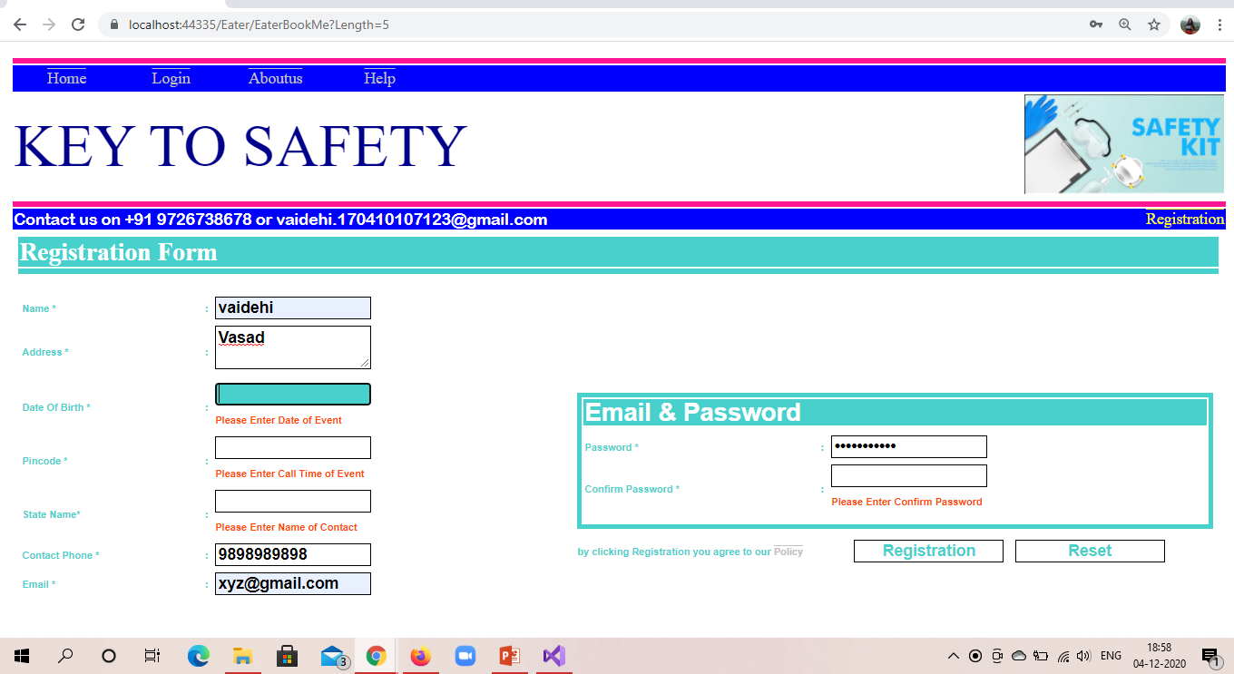

Next second image shows the full registration form filled with all details.

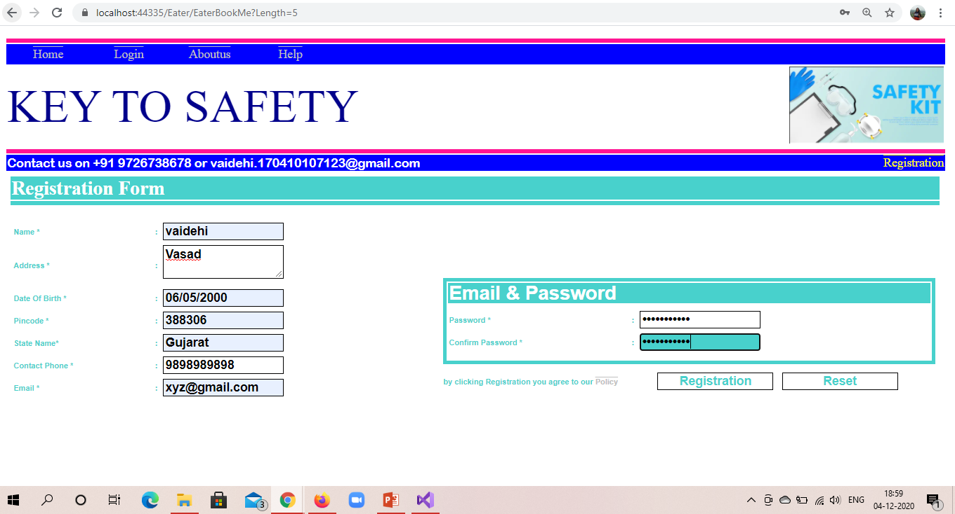

**Login :**

Here, first figure shows the invalid login details.

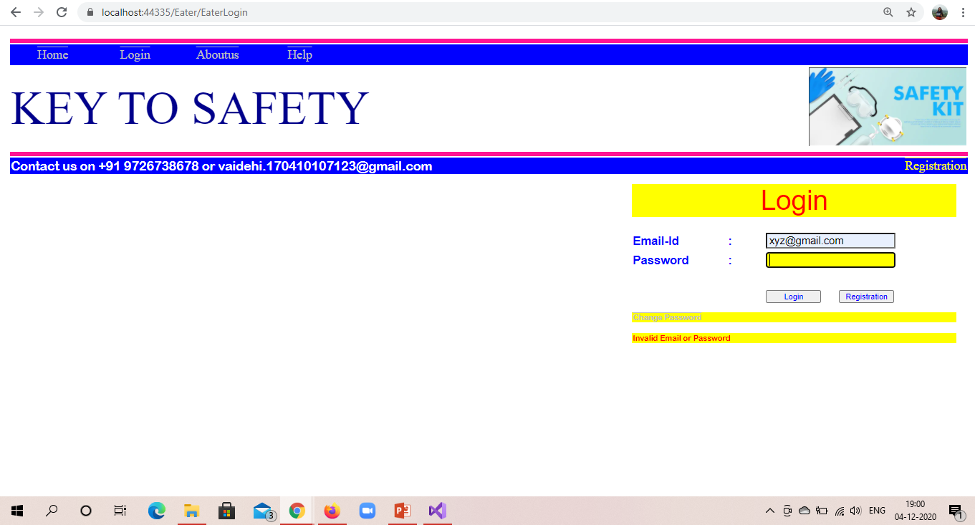

Second figure shows the valid login details.

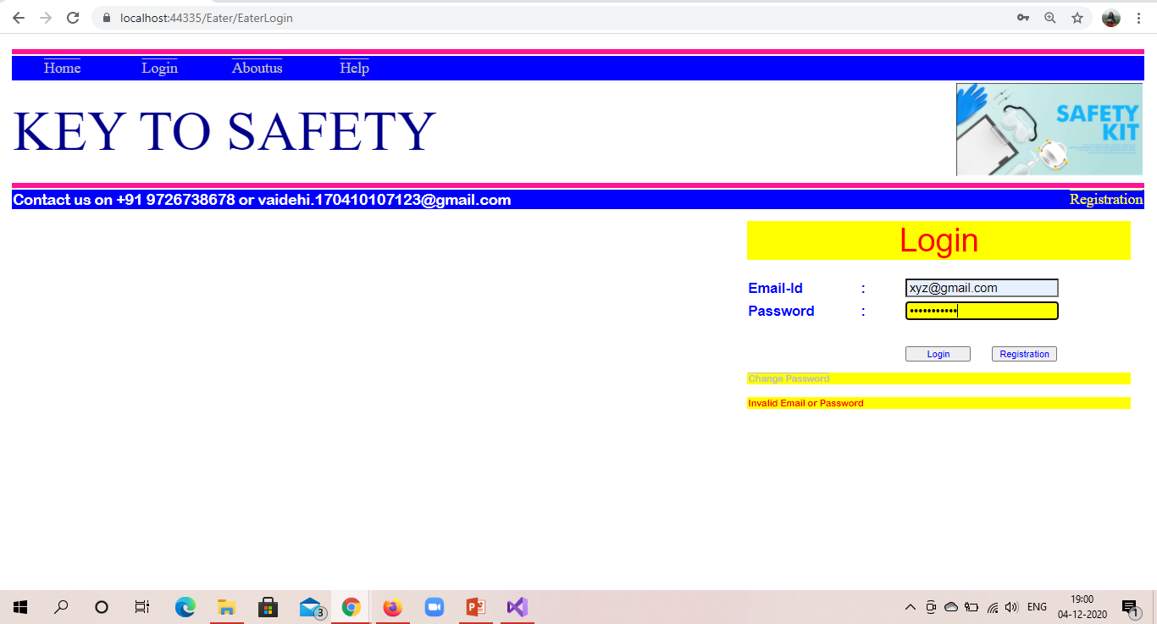

**Database from admin side:**

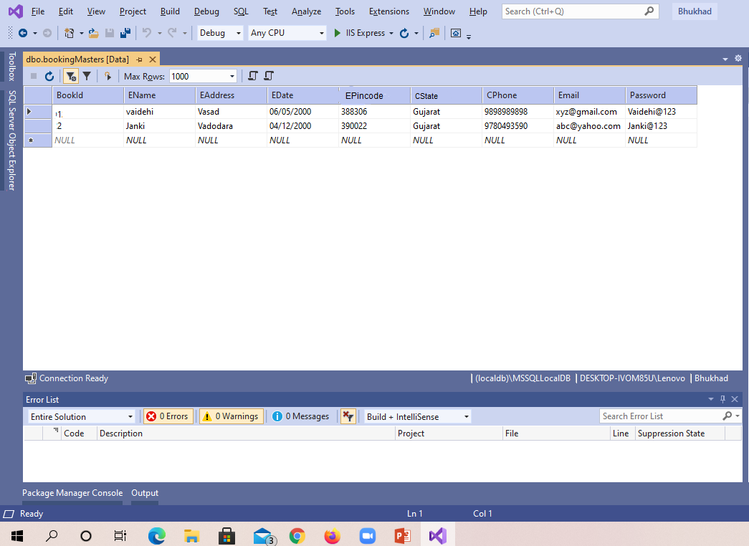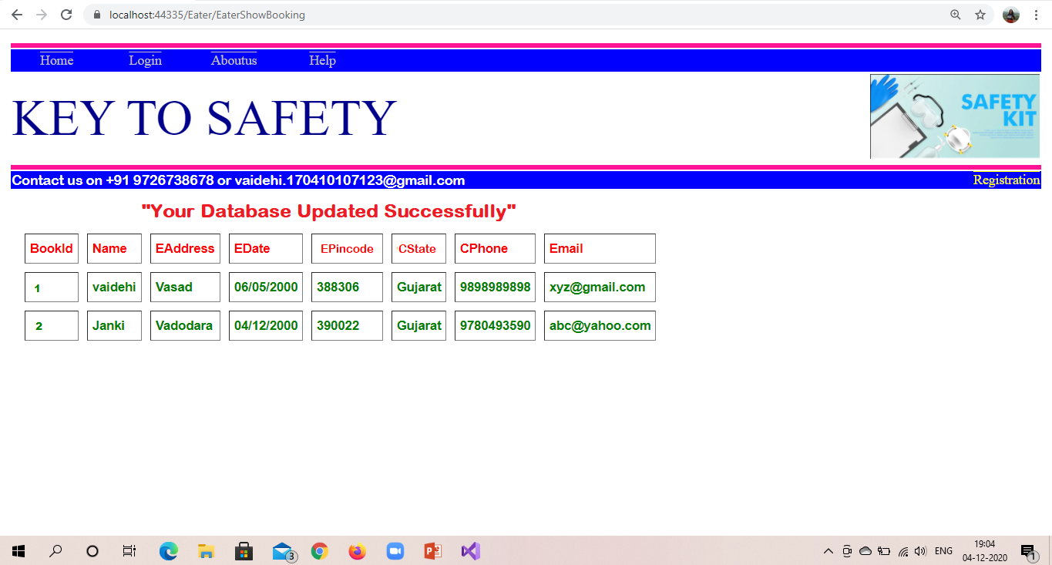

**Update Profile from admin side:**

